Building Goal form
Monday, November 10, 2025
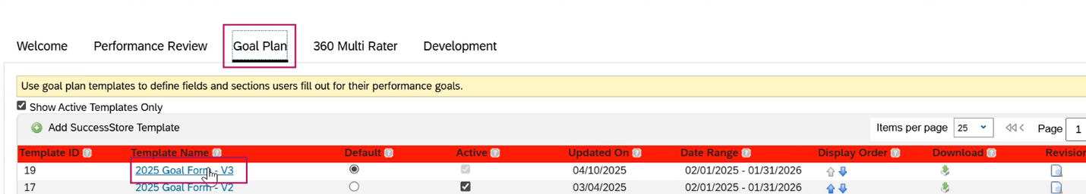

2026 Goal plan
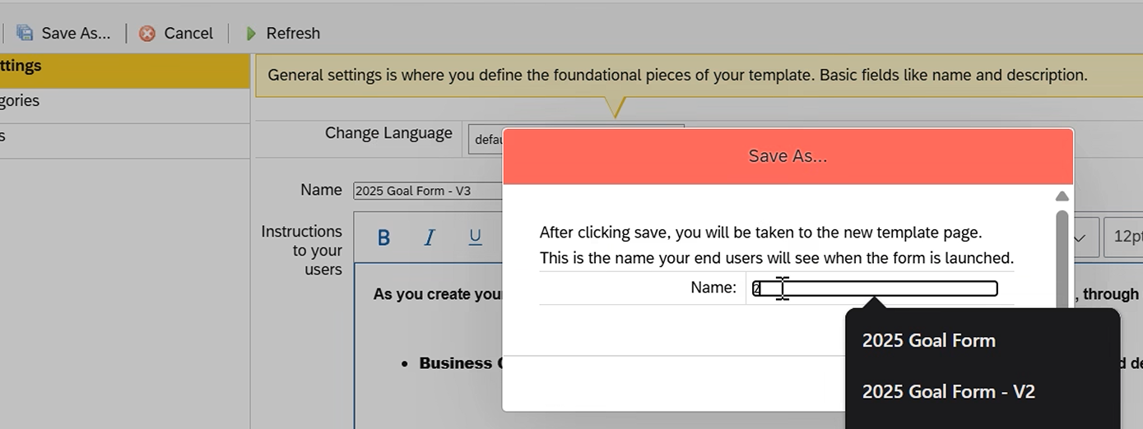
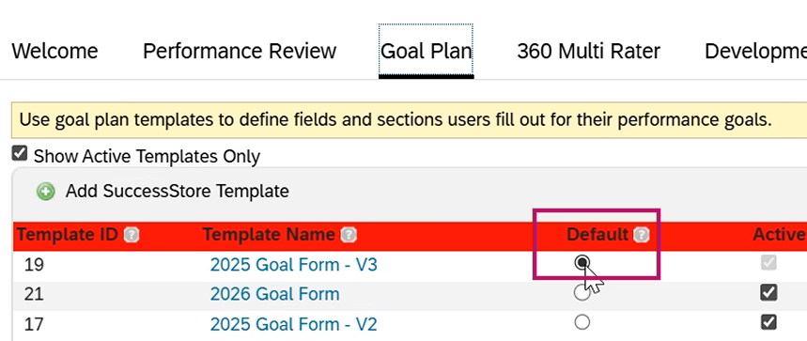

Update anything that is saying last year and update with the next year.

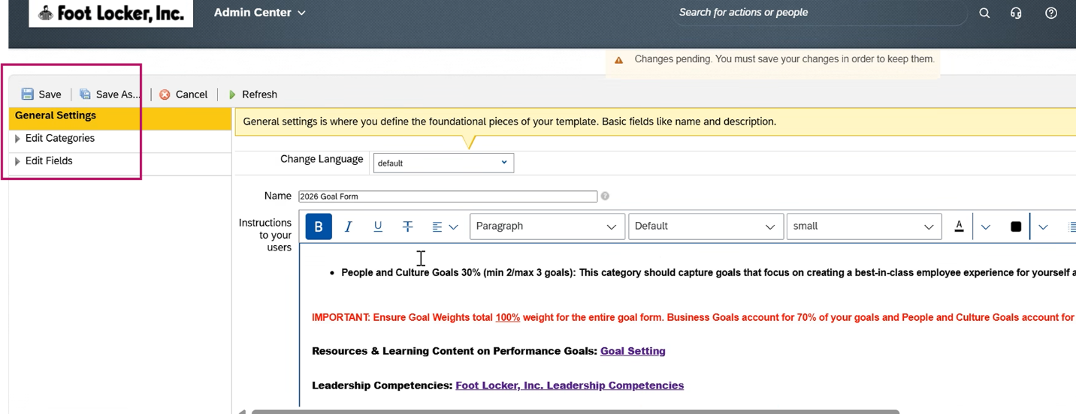

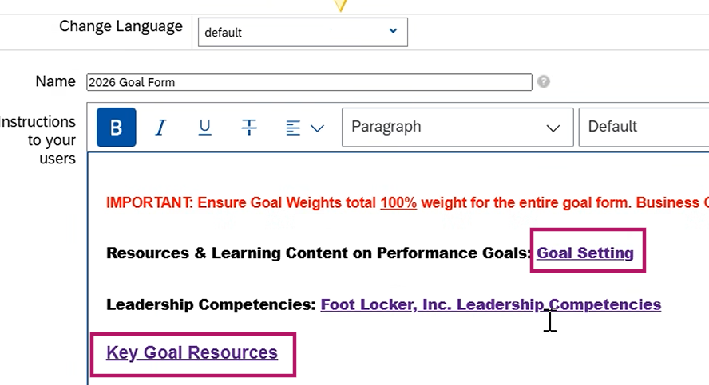

Change to display next year's fiscal year
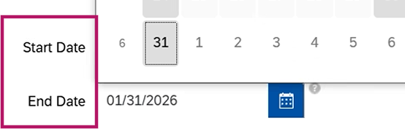

As long as % es are not changing, we are good. If Anything on the label changes, we will need to let Rizing know for updating on the backend to update calculation
Ask TM: If the % changing , If the min & max changing
